Small-Parts Assembly Line Education and Construction

1 **David DiMaggio,** *Florida State University, Mechanical Engineering*, dcd14@my.fsu.edu

2 **Boluwatife Olabiran**, *Florida Agricultural and Mechanical University*, Mechanical Engineering, boluwatife1.olabiran@famu.edu

3 **Cheyenne Laurel**, *Florida State University*, Mechanical Engineering, crl15d@my.fsu.edu   
4 **Nataajah Taylor**, *Florida Agricultural and Mechanical University,* Electrical/Computer Engineering, nataajah1.taylor@famu.edu

5 **JoEll Williams**, *Florida Agricultural and Mechanical University*, Electrical/Computer Engineering, joell1.williams@famu.edu

ABSTRACT

This paper identifies the process that is required to fulfil the requirements for the production of an educational tool to be used for Tallahassee Community College’s (TCC) Advanced Manufacturing and Training Center. The project has a focus on Manufacturing Engineering education with an introduction into Programmable Logic Controller technology. The requirements will be enacted through the construction of a modular small-parts assembly line that will detect the size and material of the small object. The object will then be sorted accordingly by a diverter arm that is attached to a Servo Motor. The ability to manipulate software and hardware to produce failures for educational purposes was required for the full utilization of the project. Different modes of failure are also examined to offer troubleshooting and inclusive curriculum options. Concept selection, programming background, and physical code are also inspected to emphasize the educational purpose of the project.

**Key Words:** Mechatronics, Manufacturing, Engineering Education

# 1. INTRODUCTION

Manufacturing Engineering is a specialized field of engineering that integrates machines and programming to create a product almost autonomously. This requires motors to respond to an input received from a sensor or group of sensors. For the assigned project, the group was required to provide an educational tool in the form of a small part assembly line that is programmed using a Programmable Logic Controller (PLC). A PLC is an industrial computer ruggedized and adapted for the control of manufacturing processes, such as assembly lines. A PLC is different from regular coding because it uses a language called Ladder-Logic programming.

* 1. **Ladder Logic**

Ladder Logic programming got its start from electrical ladder diagrams. It uses AND, OR, and NOT logic to operate relays that open and close to alter current flow. It is called Ladder Logic due to the construction of the programming with two vertical rails and then horizontal rungs between. The devices interact on the rung through assigned symbols that use memory bits to control the real-world operation of the corresponding device. Ladder circuits tend to have a few things in common between them as listed below:

1. Power bar on the far left.

2. Current flows from the interactive switches to allow flow.

3. One or more relay coils at the right.

4. Neutral or negative power bar on the right.

STOP and START mechanisms are used to control the current flow. STOP mechanisms are normally closed devices that tend to be in series on the rung, and can include limit switches, pushbuttons, or signals from a proximity switch as is with this project. START mechanisms are normally open devices and can also be utilized through pushbuttons and limit switches. Below is a schematic of what a rung in the programming may look like.

Figure 1: Example of Ladder Logic Rung

The Switch contacts seen here are represented by pushbuttons that will be stopping and starting the initial current flow, which will then need to pass through the relay contacts that will open or close the circuit. The relay coil will send power to the corresponding device if all conditions are met inside the programming. Relays play a very important role in the PLC. Once the relay is opened using only a small current, large amounts of current are able to pass through to supply power to the device.

The physical programming operates using memory bits (a 1 or 0) to represent the state of the physical device such as the relay contacts and relay coils. Each input and output is assigned a memory address that is read by the central processing unit (CPU). Upon starting the RUN cycle of the PLC, the CPU will read the inputs and update them in the memory file, then the program will run from the top left of the logic, through the last rung where it will update the outputs, and then continue to loop as long as the CPU is in RUN mode.

While Ladder Logic is a form of Relay Logic, PLC’s are much more useful than standard Relay Logic due to many convenience factors. PLC’s have solid state relays, which do not have mechanical contact and therefore do not fatigue, and instead switches on or off when a small external voltage is applied across its control terminals. They also tend to have the relays built into the PLC which only require a one wire output, while other standard relay systems can require up to four wires per device per output. This makes initial connecting and troubleshooting much more accessible. PLC’s also tend to have most components such as timers, counters, and internal relays built in prior to programming, while Relay systems would require a separate component

# 2. METHODS

There are multiple ways to carry out the process of sorting various objects based on various parameters. Described here is only one of those ways:The assembly line consists of the a cubical object to be sorted – either metallic, plastic, or glass in nature, two conveyor belts – connected perpendicular (900) to each other, a photoelectric sensor – to determine the size of the object, a capacitive sensor – to determine the material of the object, a diverter arm – to sort the object, four bins to store the sorted objects, and a Programmable Logic Controller (PLC) – to control the whole sorting process. Each of these components will be discussed in detail later. The object to be sorted starts at the beginning of one of the conveyor belts (of which neither stop moving to maximise efficiency). Then the size and nature of the object is determined. After which the object is sorted into one of the four predetermined bins corresponding to the size and shape of the object with the aid of a diverter arm bar connected to a servo motor. Four bins were selected for the sake of simplicity and practicality of the project. If for simplicity’s sake, the object can only be either a small plastic, small metal, big plastic, or big metal; the four bins represent a storage mechanism for each of those possibilities.

An overview of how each of the components function and their role in the overall process is outlined below:

1. Size Determination: In order to accomplish the overall goal of sorting an object based on size and nature, the size of the object has to be measured. To do this, a reflective photoelectric sensor sends out a beam of light and measures the time taken for the light to reflect to the source (or hit the receiver behind). Since the speed of light is known, the size of the object can be calculated by measuring the time taken for the light to hit the receiver from when the disturbance (presence of the object) occurred.
2. Material Determination: the material of the object also must be determined. For the scope of the project, only three materials were considered, although the programming is flexible enough to be applied to various other material types. The material types considered are metal, plastic and glass. To determine the material of the object, a capacitive sensor was used. A capacitive sensor fundamentally measures the difference in capacitance of whatever lies ahead of it. This makes a capacitive sensor ideal for detecting a wide range of materials. In the case where different types of metals are to be measured, as opposed to different types of materials overall, an inductive sensor would be much better. Because of the modular nature of the project, an inductive sensor was also assembled, should the need to use it arise.
3. Sortation: after the size and material composition of the object of been determined, the material then has to be sorted into a predetermined bin for objects of its type. To do this, a diverter arm bar mechanism was implemented. This mechanism consists of a 3d printed arm connected to a servo motor. The servo motor then directs the arm to a specific angle which in turn shifts the object to its required position. The servo motor was selected due its high precision, speed, velocity control, and its feedback mechanism. This feedback mechanism is useful because it detects if there is any failure in the sorting process – for example: power failure, unexpected object or emergency shut-off and then adjust itself to where it should be. Exactly four angles were selected to sort the objects; 0o, 23.28o 46.97o, and 65.28o. These four angles were selected because they maximise the use of the two conveyor belts to sort into each of the four bins.
4. Logic and Control: the processes described above would be useless on their own without some form of “brain” to coordinate every task. A microcontroller such as an Arduino Board could easily suffice for a hobby project, however, the current standard in the Manufacturing industry is a Programmable Logic Controller. This is due to the rugged nature and flexibility of the PLC. It is also highly specialized for manufacturing as opposed to other microprocessors developed to be used for a wide variety of application. The PLC used for this project is the Allen Bradley MicroLogix 1100. It was selected for its practicality for the project and simplicity. The PLC takes in the size and material information from the sensors, stores this information, processes this information to determine what bin the object should be sorted into, and then direct the servo motor (and in turn the diverter arm) to the predetermined angle (which is also stored in the PLC).

**2.1. Failure Modes and Effects Analysis**

The assessment of the possible failures that can occur within the system is a key aspect when designing the system. Failure Modes and Effects Analysis (FMEA) is a tool that assesses the severity, occurrence, and detection of the failure inside the system, and produces a Risk Priority Number (RPN). The higher the RPN is for a component of the system, the greater the risk that component poses to the system as a whole. Below is the FMEA Table for the Simulated Assembly Line. The highest RPN values are highlighted in yellow.

Table 1: Failure Modes and Effects Analysis Table



The highest RPN values pose the greatest threat to the operation of the system. The greatest risk is the PLC Software. Incorrect coding will result in a lot of useless machinery if there is no brain to operate it all. This makes the programming priority one during the construction, and testing and validation phases. The second most vulnerable part of the system is the Servo Motor due to the increasing possibility of failure if not in a controlled environment. Measures simply have to be taken to ensure that all unnecessary power, movement, and other outside factors are reduced or eliminated. Lastly, the sensors require upkeep and proper initial calibration in order to succeed. This can be done by always checking the output of the sensors to their required values each time before operation.

# 3. System construction and validation

During the concept generation and selection process, the group wanted to focus on the simplicity of the project by trying to keep the number of moving parts to a minimum. Most moving parts will need to be integrated into the system by including the device in the programming, which becomes more difficult. This why the group only chose a single arm that will move to sort the objects. The conveyor belt will not be included in the programming since it would require cutting wires to make connections inside the belt motor that is already assembled.

To begin, the system will only function properly if each component is in its correct position. Once those items are acquired and arranged according to the CAD diagram below, then the wiring connections and programming of the PLC can begin.

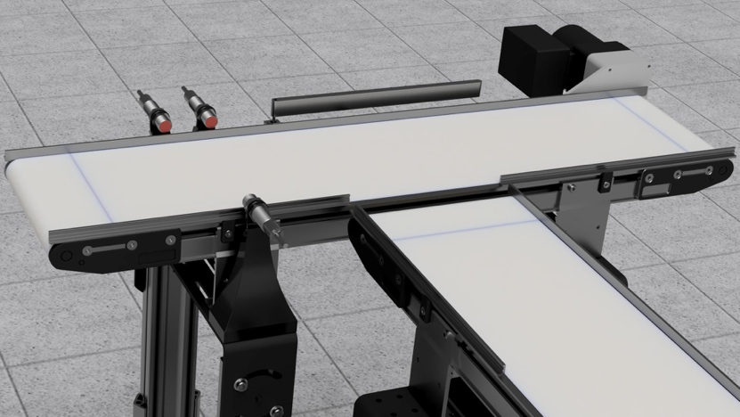

5

1

2

3

4

6

Figure 1 : CAD Rendering of Assembly Line

1. Photoelectric Sensor with accompanying Reflector located on other side of conveyor belt.
2. Inductive Sensor located next to the Photoelectric Sensor.
3. Servo Motor located on side of conveyor belt.
4. Diverter Arm mounted to Servo Motor.
5. PLC located underneath conveyor belt to save space and visual aesthetics.
6. Conveyor Belts perpendicular to each other with one the horizontal belt being slightly higher than the vertical belt to ensure smooth transitioning.

## 3.1. Programming Construction and Integration

1.

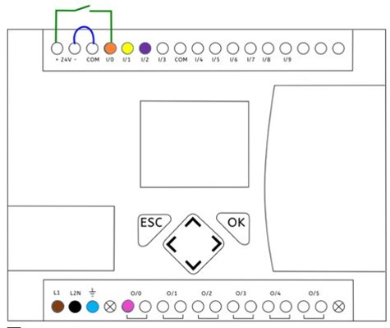

**Legend**

1. **DC Power Supply** ​

**Brown** –Connect to +24 V terminal  ​

**Black** – Connect to –24 V terminal ​

**Blue** – Grounded to 0 V ​

1. ​**Inputs** ​

**Orange** - Inductive sensor port ​

**Yellow**- Photoelectric Switch  ​

**Purple** – Capacitive Sensor​

1. ​**Output(s)** ​

**Pink** – Servo Motor port

Figure 3: Wiring Diagram of PLC

Above is the wiring diagram for the PLC, which shows where to wire the inputs and outputs of the system.

**4. RESULTS**

PLC programming has served issues with programming as the lite version of the software gave difficulties with programming the servo motor. The mounts for the conveyor belts are 3D printed and are placed firmly onto the sides of the conveyor belts. All sensors and MSP430f5529 fits within the sensor mounts. The programming of the sensors and stepper motor was used with the MSP430f5529 microcontroller and the Energia programming software. Using this program allowed secured results from the system. Because there was a use of the MSP430 there is also a need for a breadboard to connect all sensors and servo motor to the microcontroller. There are success attempts to running the stepper motors being programmed to turn in positions needed. The sensor connection of the photoelectric sensor has failed due to the lack of the reflector XUC50 for the photoelectric sensor.

**5. DISCUSSION**

Programming the PLC was the most important stage of the project since it was the brain that allowed the whole system to operate as a unit. Ladder Logic programming is a much more visual programming language, which makes the physical correlation between the ladder logic code and the system’s actions easier to teach in an educational setting. PLC’s also offer a degree of a flexibility when expanding or retracting the functions of the system, which ensures a modular system that is easily capable of expansions or retractions of its functions. The adaptability of the project was key in the educational purpose of the assembly line. An operation manual with pseudo code is required to fulfil the educational intentions for the system. This gave the team a full insight into the possible failures and the effects the failures would have on the system upon testing and validation, which turned out to be the PLC itself. The first PLC that was shipped in failed to turn on at all. This prompted the team to borrow a different PLC that was still a MicroLogix 1100, but had a training circuit board previously attached. This actually made the group’s efforts easier since the wiring connections were more accessible. Once testing began on the PLC the team had trouble signalling output to the stepper motor.

**6. SUMMARY**

In this paper, we describe the steps taken to create a machine that was complex yet simple enough to serve as a Mechatronics certification tool for Tallahassee Community College and discuss each of the components used to build such a tool. The Simulated Assembly Line and Processing Workstation enables students to get real experience with evaluating complex systems to find solutions to the problems at hand. To accomplish the educational side of the system, a modular integration was implemented by allowing parts to be easily interchanged and added. Also, various failures can be applied to the system, ranging from software failures such as miscalculations in the applied logic or incorrect syntax (wrongly written code), to hardware failures such as poor wire connections or faulty equipment, to name a few. The system exposes students to various components that act as the industry standard today, such as Programmable Logic Controllers (PLCs), sensors, and motors. This better prepares for employment and equips the students with the experience needed to function in whatever company they might work.

The ability the allow errors to occur or be purposely implemented was key for the educational aspect of the project. Errors and malfunctioning occur every day in the real world, and it is important to be able to diagnose and rectify the issue. For example, an unforeseen failure occurred when the first PLC failed to turn on. Luckily the group was able to acquire another PLC, but this did delay the acquisition of the system’s success or failure. The group is working with the new PLC to run the written code for testing and validation purposes.

**7. FUTURE WORK**

Since the system is capable of being expanded upon, future work lies in the progression of the assembly line in the classroom setting. The students that use the assembly line as their learning tool will be the potential for the advancement of the system. Other purposes such as material extrusion or detection of specific shapes can be included to enhance the performance and practicality of the assembly line. The project offered students a more hands on learning approach that will hopefully give TCC’s Advanced Manufacturing and Training Center students the experience requires to succeed in the manufacturing field.

REFERENCES

List of references must follow **A.P.A. style**.

1. What is Ladder Logic? (2019, January 09). Retrieved from

https://library.automationdirect.com/understanding-ladder-logic/

1. What Are the Advantages PLCs Have over Relay Systems | PLC Programming Courses for

Beginners. (2019, March 11). Retrieved from <https://realpars.com/advantages-plcs-over->relay-systems/

1. Solid State Relay or Solid State Switch. (2018, March 02). Retrieved from

https://www.electronics-tutorials.ws/power/solid-state-relay.html

<http://www.eng.utoledo.edu/~wevans/chap2_S.pdf>